Pollution Incident Response Management Plan
St Marys EPL 6934
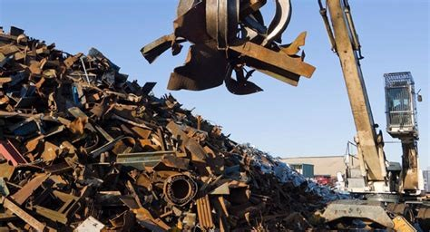
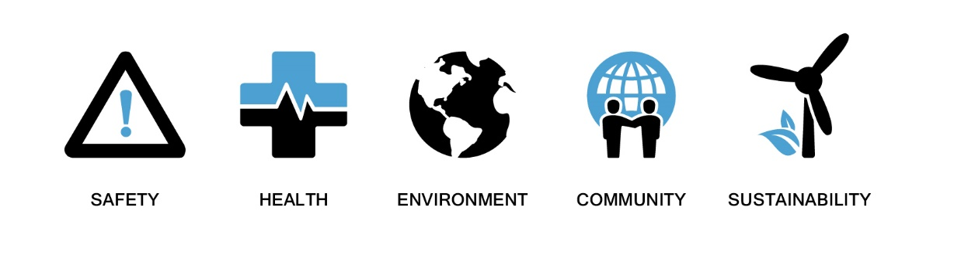

Contents
Overview 3
Purpose and Scope 3
Regulatory Requirements 4
1. Definition of a Pollution Incident 4
2. Key Responsibilities 4
2.1. Table 1 – Name, Responsibility and 24 Hours Contacts of Sims Metal Staff 4
3. Pollution Incident Notification Process 5
3.1. Requirement to Notify 5
3.2. Reporting an Incident 5
3.3. Pollution Notification Within Sims Metal 5
3.4. Pollution Notification to Relevant Authorities 5
3.5. Table 3 – Contact Numbers if there is an Immediate Threat to Human Health or the Environment – Call Fire and Rescue NSW First 6
3.6. Table 4 – Contact Numbers if there is no Immediate Threat to Human Health or the Environment – Call Environment Protection Authority First. 6
3.7. Communication With Neighbours and the Local Community 6

Overview
As the holder of EPL 6934, Sims Metal is required to comply with the POEO Act. As such this procedure has been developed to satisfy the requirements to maintain a “Pollution Incident Response Management Plan” (PIRMP).
The purpose of this PIRMP is to:
- Ensure comprehensive and timely communication about a pollution incident to workers and other persons at the premises, the Environment Protection Authority (EPA), other relevant authorities specified in the Act (such as local councils, NSW Ministry of Health, SafeWork NSW, and Fire and Rescue NSW) and people outside the facility who may be affected by the impacts of the pollution incident.
- Minimise and control the risk of a pollution incident at the facility by requiring identification of risks and the development of planned actions to minimise and manage those risks.
Ensure that the plan is properly implemented by trained workers, identifying persons responsible for implementing it, and ensuring that the plan is regularly tested for accuracy, currency and suitability.

Purpose and Scope
The POEO Act introduces several changes to improve the way pollution incidents are reported, managed and communicated to the general community. The Act includes a new requirement under Part 5.7A of the Protection of the Environment Operations Act 1997 (POEO Act) to prepare, keep, test and implement a pollution incident response management plan.
The specific requirements for pollution incident response management plans are set out in Part 5.7A of the POEO Act and the Protection of the Environment Operations (General) Regulation 2022 (POEO(G) Regulation).2 In summary, this provision requires the following:
All holders of environment protection licences must prepare a pollution incident response management plan (section 153A, POEO Act).
The plan must include the information detailed in the POEO Act (section 153C) and be in the form required by the (POEO (G) Regulation) (Chapter 4 clause 70).
Licensees must keep the plan at the premises to which the environment protection licence relates or, in the case of trackable waste transporters and mobile plant, where the relevant activity takes place (section 153D, POEO Act).
Licensees must test the plan in accordance with the POEO (G) Regulation (Chapter 4 clause 75).
If a pollution incident occurs during an activity so that material harm to the environment is caused or threatened, licensees must immediately implement the plan (section 153F, POEO Act).

Regulatory Requirements
- Definition of a Pollution Incident
A “pollution incident” for the purpose of this plan means an incident or set of circumstances during or as a consequence of which there is or is likely to be a leak, spill or other escape or deposit of a substance, as a result of which pollution has occurred, is occurring or is likely to occur. It includes an incident or set of circumstances in which a substance has been placed or disposed of on premises, but it does not include an incident or set of circumstances involving only the emission of any noise.
- Key Responsibilities
While personal details for the following are available in the PIRMP kept onsite they do not appear in this public document under the provision of the Privacy and Personal Information Protection Act 1998.
  - Table 1 – Name, Responsibility, and 24 Hours Contacts of Sims Metal Staff
Title | Name | Responsibility | Number
Yard Manager | Daniel Sweet | Activate PIRMP  Notify emergency services of the pollution incident.  Notify EHS team, Regional Operations Manager | *
Regional Operations Manager | Tim Booth | Assist Yard Manager and EHS Partner in Pollution Response | *
EHS Partner – Eastern Region APAC | Shruthi Mohan | Notify External Authorities  Coordinate Post Pollution Response | *
EHS Specialist NSW/ACT | Julie Robertson  Haylee Foley | Assist EHS Partner in Pollution Response | *
Environmental Partner APAC | Nicholas Bhugon | Assist business unit in Pollution Response | *

- Pollution Incident Notification Process
  - Requirement to Notify
Pollution incidents causing or threatening ‘material harm to the environment’ must be notified.
A ‘pollution incident’ includes a leak, spill, or escape of a substance, or circumstances in which this is likely to occur.
Section 147 of the POEO Act defines the meaning of material harm to the environment.
Harm to the environment is material if
- it involves actual or potential harm to the health or safety of human beings or to ecosystems that is not trivial, or
- It results in actual or potential loss or property damage of an amount, or amounts in aggregate, exceeding $10,000 (or such other amount as is prescribed by the regulations), and
- The loss includes the reasonable costs and expenses that would be incurred in taking all reasonable and practicable measures to prevent, mitigate or make good the harm to the environment.
For the purpose of this part, it does not matter that harm to the environment is caused only in the premises where the pollution incident occurs. This includes environmental harm within and beyond the boundary of the premises.
  - Reporting an Incident
Workers or contractors who identify any actual or potential pollution incident must immediately respond to the incident in accordance with their site emergency response plan (ERP). This includes responsibility for immediately alerting their line manager regardless of nature or scale.
Call 000 if the incident presents an immediate threat to human health or property. Fire and Rescue NSW, the NSW Police and the NSW Ambulance Service are the first responders, as they are responsible for controlling and containing incidents. The line manager supports first response actions and must immediately alert the Yard Manager.
  - Pollution Notification Within Sims Metal
On receiving a report of a pollution incident, the Yard Manager immediately assesses whether the report meets the criteria of a pollution incident. If the criteria are met the Yard Manager must immediately contact in the first instance the EHS Partner if contact cannot be made the Regional Operations Manager.
On receiving a report of a pollution incident in the first instance the EHS Partner if contact cannot be made the Regional Operations Manager must ensure that:
- The incident is immediately assessed on the information provided to establish if:
- It is a pollution incident.
- It is a notifiable incident.
- It has been notified to relevant authorities such as Fire and Rescue NSW – 000

- The following information is to be included:
- Incident location and estimated quantity of pollutant(s) involved
- Incident description (date, time, duration) and cause if known (do not speculate)
- Immediate actions are taken to address the pollution incident (do not speculate)
The Yard Manager remains responsible for managing the direct response to the pollution incident.
For any fires after hours, the off-site security monitoring room must first dial 000 and inform the fire brigade first followed by contacting relevant SIMS workers for St Marys.
  - Pollution Notification to Relevant Authorities
On determining that the incident is a notifiable incident the EHS Partner or Regional Operations Manager must immediately notify each relevant authority. For the purposes of this document immediately means “promptly and without delay”. If the incident does not require an initial combat agency, or once the 000 call has been made, notify the relevant authorities in the table Protocol for Industry Notification in the order listed.
  - Table 3 – Contact Numbers if there is an Immediate Threat to Human Health or the Environment – Call Fire and Rescue NSW First
Industry Notification | Contact Number
Fire and Rescue NSW | 000
Environment Protection Authority | 131 555
Public Health Unit | 02 9845 5555 (Westmead Hospital) Adult Unit  Ask for Public Health Officer On Call
SafeWork NSW | 13 10 50
Penrith City Council | 02 4732 7777  Ask for Environmental Health Department or after Hours Leave a Message.

  - Table 4 – Contact Numbers if there is no Immediate Threat to Human Health or the Environment – Call Environment Protection Authority First.
Industry Notification | Contact Number
Environment Protection Authority | 131 555
Penrith City Council | 02 4732 7777  Ask for Environmental Health Department or after Hours Leave a Message.
Public Health Unit | 02 9845 5555 (Westmead Hospital)  Ask for Public Health Officer On Call
Fire and Rescue NSW | 1300 729 579

  - Communication With Neighbours and the Local Community
The EHS Partner or Regional Operations Manager shall determine requirements for community notification following the methodology as required.
- Early warning by telephone notification to nearest and other neighbours that maybe affected over the subsequent 24-hour period.
- Regular updates to nearest neighbours and other neighbours who may have been notified in the early warning notification.
- Updates to the broader local community if affected by newsletters, Sims Metal Website, media statements etc.
Information provided will be relevant to the incident and may include details such as:
- The type of incident that has occurred.
- The potential impacts to neighbours and the community
- SMM representative contact details
- Any advice or recommendations based on the incident type and scale
The Environmental Community Feedback Hotline has been established to comply with environmental legislation. This service is intended for community members who do not have contact details for SIMS Management. As required by legislation, the hotline must be publicly available on the SIMS website and can be found here - Reporting - Sims Metal AU.
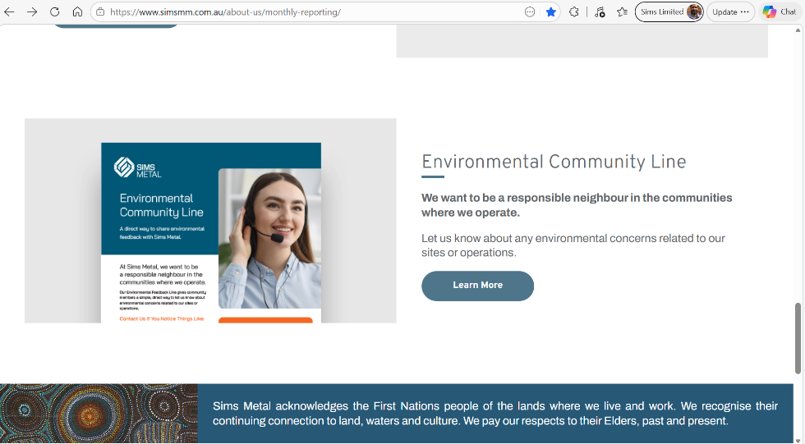
Document Control
Name: |  | Pollution Incident Response Management Plan – St Marys
Document No.: |  | PIRMP_NSW_EMS_PLN_V2.10
Version No.: |  | 2.10
SHECS Management System: |  | Planning and Prioritising 2.4 Emergency Preparedness
Effective Date: |  | 27.05.2026
First Issued Date: |  | 1 September 2012
Owner: |  | EHS NSW/ACT
Region: |  | New South Wales
Uncontrolled Copy if Printed: |  | Please refer to Sims intranet for latest version before using this document. Always check to be sure you have the most up-to-date version.
Change History
Issue | Date | Description of Change
1.0 | 01/09/2012 | Initial Release
1.1 | 12/11/2012 | Update table 3.3 Remove Adrian O’Flynn
1.2 | 12/11/2012 | Update EPA Draft Audit Report Jan-13 and change number for Fire and Rescue NSW
1.3 | 25/09/2013 | Annual review Update Contact Table, total review and update
1.4 | 30/09/2014 | Annual review Update Contact Table, total review and update
1.5 | 30/09/2015 | Annual review Update Contact Table, total review and update
1.6 | 30/09/2016 | Annual review Update Contact Table, total review and update
1.7 | 30/09/2017 | Annual review Update Contact Table, total review and update
1.7.1 | 10/11/2017 | Review required due to activation of the PIRMP following incident 12/10/17
1.8 | 30/09/2018 | Annual review Update Contact Table, total review and update
1.8.1 | 26/10/2018 | Review as directed in Waste Operations - SWC -Out - Letter SIMS St Marys EPL 6934 2017 2018 Annual Return, PIRMP and R3.3 report from fire Oct 2017
1.9 | 27/09/2019 | Annual review Update Contact Table, total review and update
2.0 | 29/09/2020 | Annual review Update Contact Table, total review and update
2.1 | 29/09/2021 | Annual review Update Contact Table, total review and update
2.2 | 28/01/2022 | Update to Appendix A – Test and Training Register
2.3 | 30/09/2022 | Annual review Update Contact Table, total review and update
2.4 | 21/02/2023 | Changes made to contacts with removal EHS Business Partner and Enviro
2.5 | 04.09.2023 | Reviewed grammatical changes. Addition EHS Business Partner and EHS Specialist to contact list.
2.6 | 20.09.2024 | Reviewed. Additional changes to responsible roles.
2.7 | 2/12/2024 | Reviewed. Update to Section 3.1 ‘Requirement to notify’ – Clarity on notification requirements.  Updated the definition of ‘immediately’ in Section 3.4 Pollution Notification to relevant authority  Included the off-site security monitoring room in 3.3
2.8 | 24/11/2025 | Reviewed
2.9 | 03/12/2025 | Reviewed in preparation of EPA visit to site. Updated diagrams to show storage location
2.10 | 27.05.26 | Reviewed to include environmental community feedback hotline.

